Year Group | Autumn 1 | Autumn 2 | Spring 1 | Spring 2 | Summer 1 | Summer 2
R | The Owl who was afraid of the Dark by Jill Tomlinson  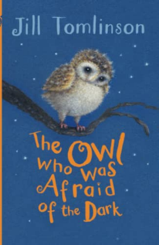 | Collection of Traditional Tales  Little Red and the Hungry Lion by Alex T. Smith  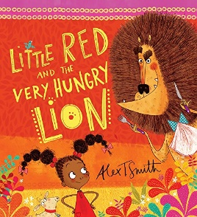  Cinderella by Chloe Perkins  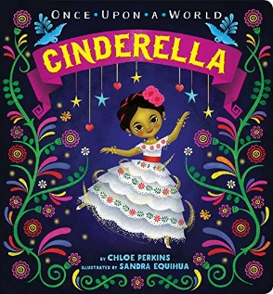  The Three Little Pigs  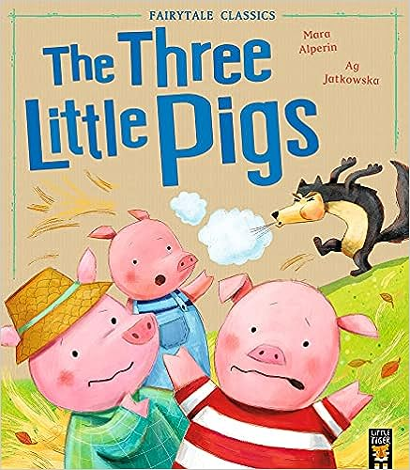 | The night Gardener by Terry Fan  Orphan/  change  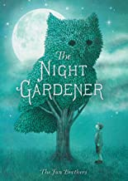 | A Bear Called Paddington by Michael Bond  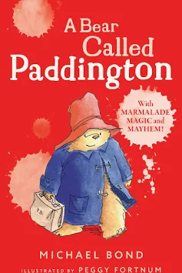 | The Fox and the Ghost King by Michael Morpurgo  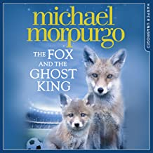 | George’s Marvellous Medicine by Roald Dahl  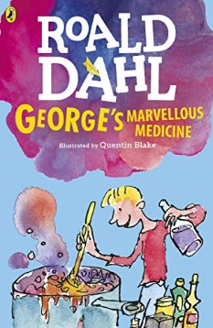
Picture books linked to hist/geog/sci | Super Duper You!  by Sophy Henn  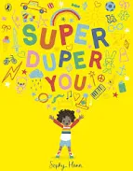  Listen by Gabi Snyder  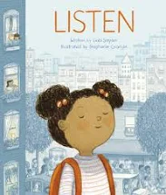  Funny Bones by Janet and Alan Ahlberg  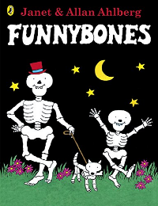  Goldilocks and the Three Bears by Susanna Davidson  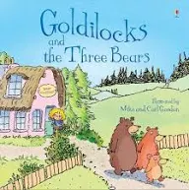  Sulwe by Lupita Nyong'o  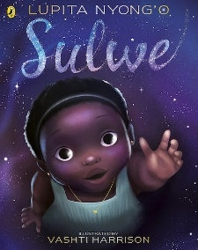 | The Best Diwali Ever by Sonali Shah  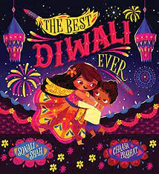  Meg and Mog by Helen Nicoll  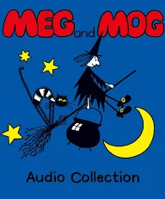  Emma Jane's Aeroplane by Katie Haworth  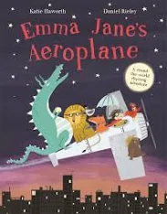  The Cat, The Mouse and the Runaway Train by Peter Bently  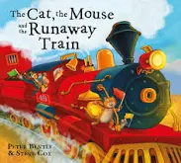 | Tree: Seasons come Seasons Go – by Patricia Hegarty  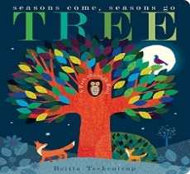  Winter Sleep:  A Hibernation Story by Sean Taylor  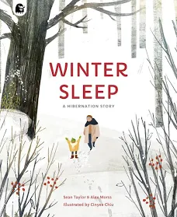  Look Up by Nathan Bryon  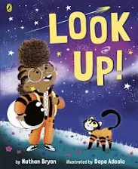  Here We Are: Notes for Living on Planet Earth by Oliver Jeffers  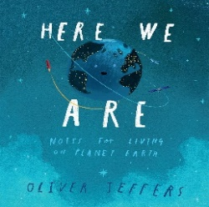 | Paddington and the Grand Tour  by Michael Bond  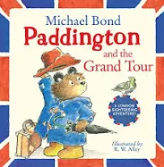  King Charles (97) (Little People, BIG DREAMS) by Maria Isabel Sanchez Vegara  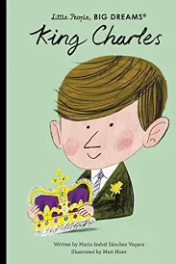  Hello Spring by Jo Lindley  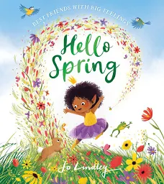 | Jack and the Beanstalk by Richard Walker  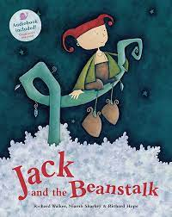  The Tiny Seed by Eric Carl  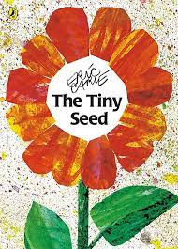  Nature’s Tiny Miracle: The Bee – journey of a bee from plant to plant  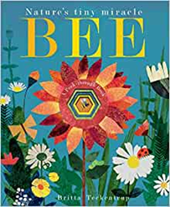  David Attenborough  -Little People Big Dreams by Maria Isabel Sanchez Vegara and Mikyo Noh  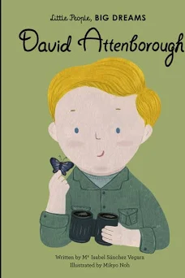  Clean Up! by Nathan Bryon  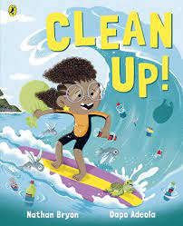 | We All Went on Safari: A Counting Journey Through Tanzania by Laurie Krebs  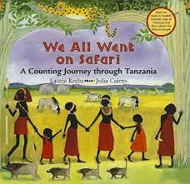  Usborne - St George and the Dragon  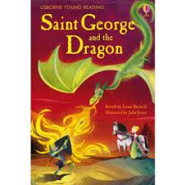  Greek Myths for Young Children by Anna Milbourne  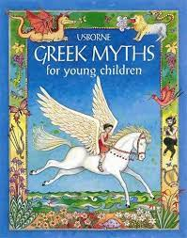  Anansi the Clever Spider by  Susie Linn  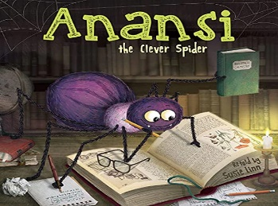
Poetry | Wiggle and Roar Rhymes by  Julia Donaldson  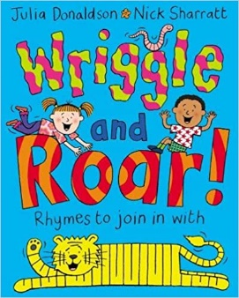 |  | Poems Out Loud by Laurie Stansfield & Various Poets  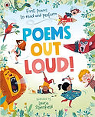 |  | Michael  Rosen’s Book  of Nonsense  Poems  Wriggle and  Roar Rhymes  by Julia  Donaldson  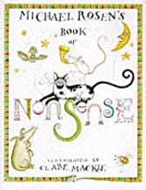
Everyone’s Welcome | Ten Little pirates – Mike Brownlow – differences in pirates  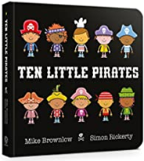 | What Happened to You?:  by James Catchpole  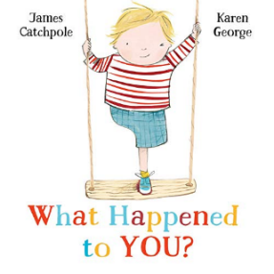 | My World, Your World – Melanie Walsh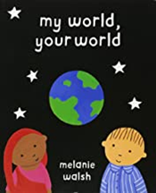 | The Family Book – Todd Parr – Differences  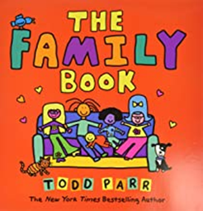 | Blue Chameleon – Emily Gravett – Changing to fit in  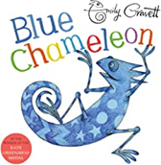 | Worm loves Worm – J.J Austria  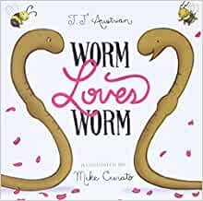
1 | The Twits by Roald Dahl  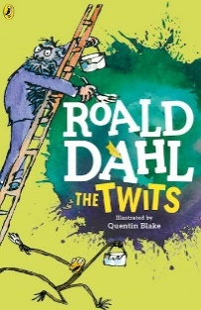 | Angel on the roof by Shirley Hughes  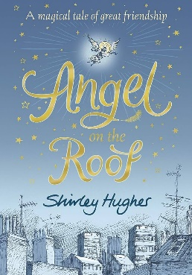 | 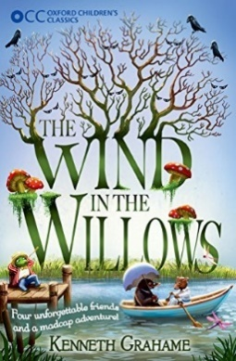  The Wind in The Willows by Kenneth Grahame | 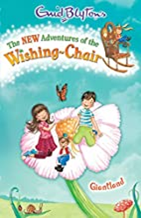  Adventures of the wishing chair by Enid Blyton | The Boy who grew Dragons by Andy Shephard  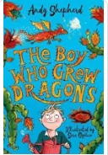 | 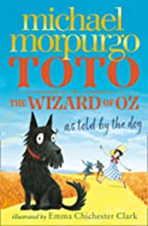  Totto – The wizard of Oz by Michael Morpurgo
Picture books linked to hist/geog/sci | The Magic Family by Lotte Jeffs  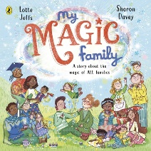  Listening to my Body by Gaby Garcia  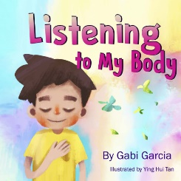 | Rosalind Franklin (65) (Little People, BIG DREAMS) 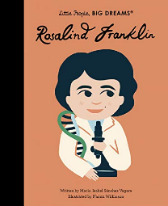  Tidy by  Emily Gravett  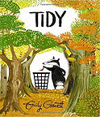 | What did the Tree see?  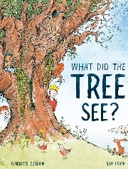  Charlotte Guillian  Bringing the Rain to Kapiti Plain  by Verna Aardema  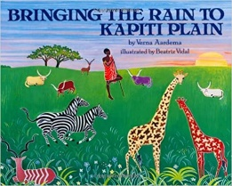 | There Once is a Queen  Michael Morpurgo & Michael Foreman  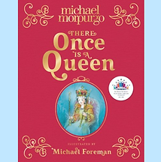  Dear Greenpeace by Simon James  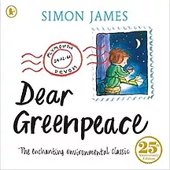  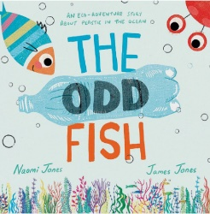  The Odd Fish by Naomi James | Ten Seeds-Ruth brown 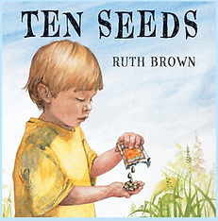  A Little Guide to Wild Flowers  Charlotte Voake  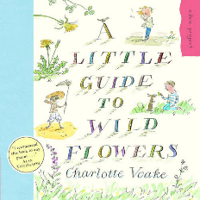 | How to Build a City  by Isabel Otter and Harry Woodgate  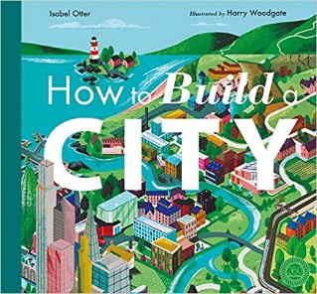  Info Buzz: The United Kingdom  By Izzi Howell  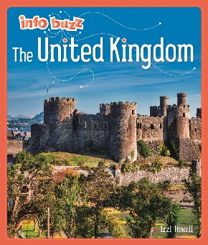
Poetry | Ready for Spaghetti – Funny Poems for Funny Kids  Michael Rosen  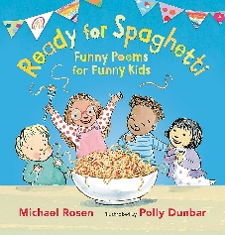 | Michael Rosen's A-Z: The best children's poetry from Agard to Zephaniah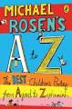 |  | We Are Britain!  Benjamin Zephaniah and Prodeepta Das  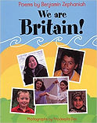 | A First Book of the Sea by Nicola Davies & Emily Sutton  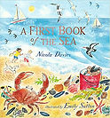
Everyone’s Welcome | You Choose – Nick Sharratt and Pippa Goodhart – Personal Choice  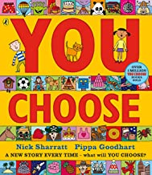 | Hair Love  Matthew Cherry & Vashti Harrison  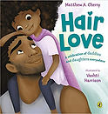 | Ivy and the lonely raincloud – Katie Harnett  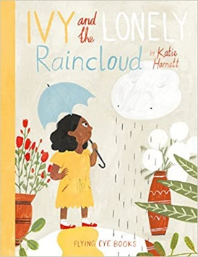 | Rabityness – Jo Empson  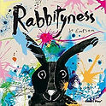 | The Little Gardener  Emily Hughes  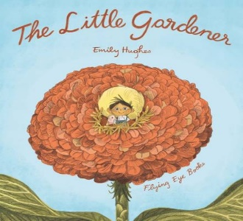 | In My Mosque: A big-hearted celebration of mosques and their communities  by M. O. Yuksel  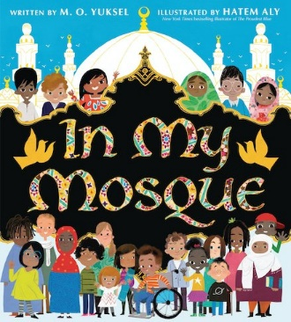
2 | SPATIAL/ MATERIALS AND MATTER | ROMANS/LIVING THINGS | BRITISH ISLES/ELECTRIC | TUDORS/ HUMAN BODY | NORTHERN EUROPE/PLANTS | POWERFUL VOICES/ASTRONOMY
 | The Iron Man  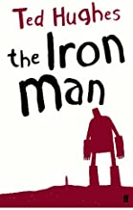  By Ted Hughes | Charlotte’s Web by E.B White  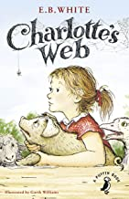 | Twelfth Night  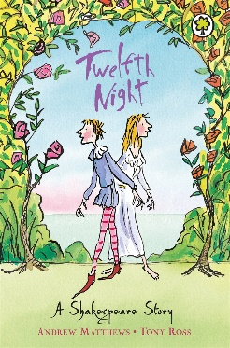 | Too Small Tola  By Atinuke  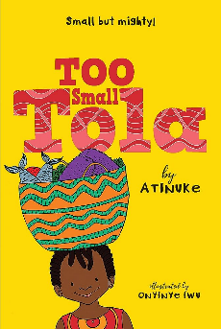 | Leonara Bolt – Secret Inventor by Lucy Brandt and Gladys Jose  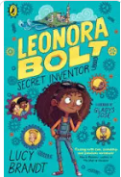 | Winnie the Pooh by AA Milne  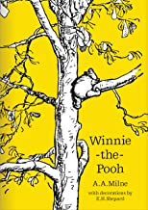
Picture Books linked to hist/geog/sci | The Tin Forest by Helen Ward  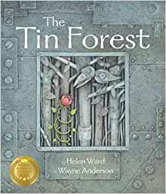 | What the Romans did for us.  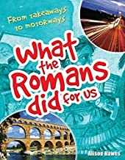 | The Boy Who Harnessed the Wind: Picture Book Edition  by William Kamkwamba , Bryan Mealer  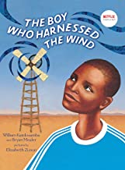 | Here we are: notes for Living on Planet earth – Oliver Jeffers  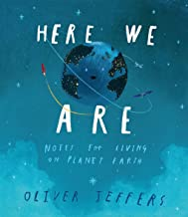 | Big Book of Blooms -Yuval Zommer  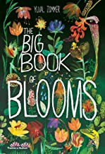 | Curiosity: The Story of a Mars Rover by Markus Motum  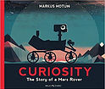
Poetry | A Kid in My Class: Poems  by Rachel Rooney and Chris Riddell 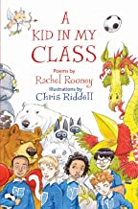 |  | 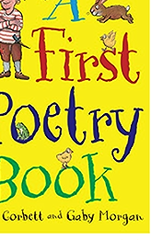  A First Poetry Book by Pie Corbett | Apes to ZebrAS -Shape Poems  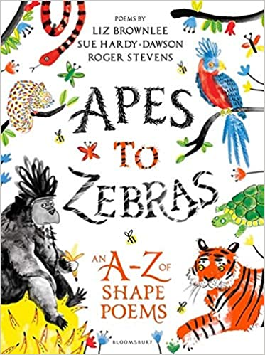 |  | Poems from around the world – Big Book  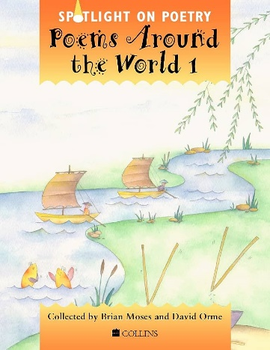
Everyone’s welcome | Shine by  Sarah Asuquo  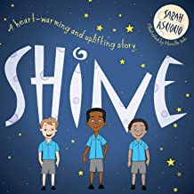 | The Way Back Home by Oliver Jeffers (Unlikely Friendship)  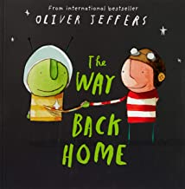 | The Great Big Book of Families by Mary Hoffman and Ros Asquith (Differences in families)  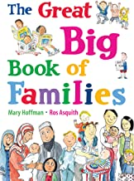 | Two Monsters by David McKee -Working together  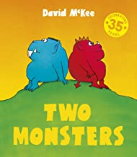 | Elmer by David McKeee (Being different)  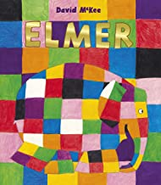 | This is Our House by Michael Rosen and Bob Graham (differences in families)  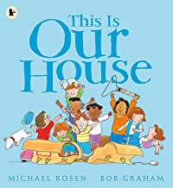
3 | ROCKS/SPATIAL/STONE AGE | HUMAN BODY/SETTLEMENTS/EGYPTIANS | LIGHT/RIVERS/VIKINGS | PLANTS/UK SOUTH WEST/ | CYCLES OF NATURE/WESTREN EUROPE/LAW AND POWER | FORCES OF NATURE/ASIA:CHINA AND INDIA/WAR OF THE ROSES
 | The Wild Robot  By Peter Brown  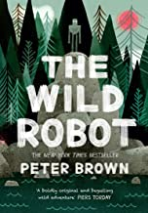 | The Last Bear by Hannah Gold  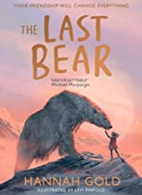 | The Tempest  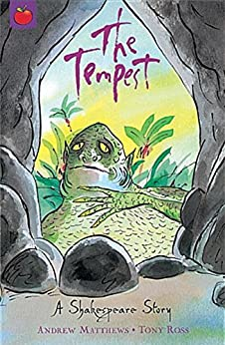  Peter Pan -Abridged  JM Barrie  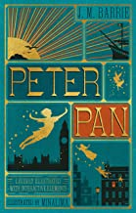  The Secret Garden(Abridged) by Frances Hodgson Burnett  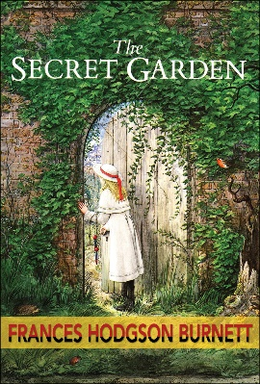 | Vetman by Noel Fitzpatrick  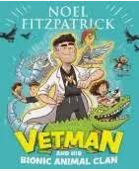 | Stig of the Dump  By Clive King  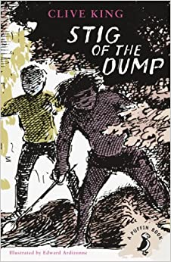 | Billy Bramble and the great big cook off  Sally Donovan  (Overcoming feelings)  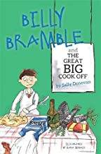
Picture Books linked to Hist/Geog/sci | The Street beneath my feet by Charlotte Guillain  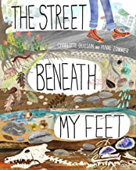 | Egyptian Cinderella  by Shirley Climo  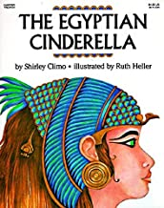 | The Dragon’s Hoard -Stories from Vikings  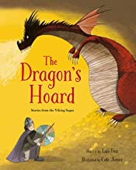 | A First Book of Nature by Nicola Davies & Mark Hearld  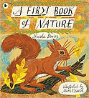 | Can You Hear the Trees Talking? Discovering the Hidden Life of the Forest  by Peter Wohlleben  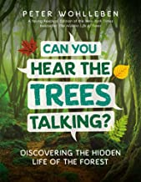 | The Willow Pattern Story by Allan Drummond  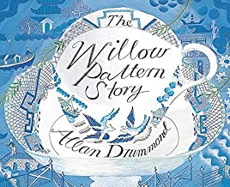
Poetry | Julia  Donaldson –  Poems to  Perform  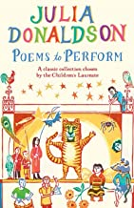 | The Puffin Book of Fantastic First Poems -June Crebbin  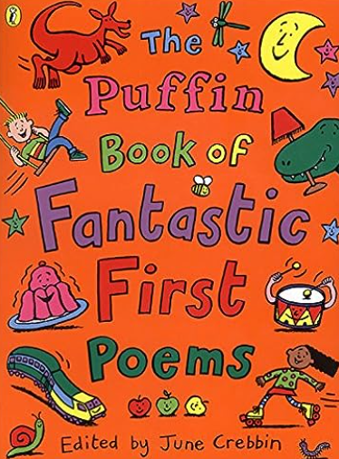 |  | National Trust: I Am the Seed That Grew the Tree: A Nature Poem for Every Day of the Year  by Fiona Waters and Frann Preston-Gannon  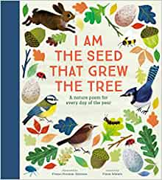 |  | An Emotional Menagerie: Feelings from A to Z: Feelings from A-Z  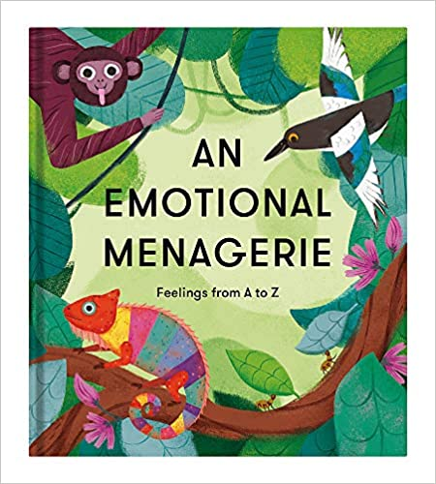
Everyone’s Welcome | Dogs don’t do Ballet by Anna Kemp and Sara Ogilive (following dreams )  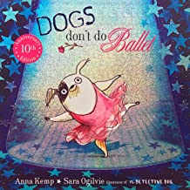 | The new Jumper by Oliver Jeffers (Being different)  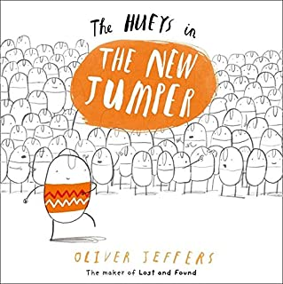 | Max the Champion by Sean Stockdale (sports and dreams)  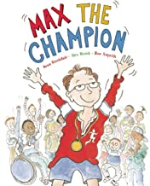 | What the Jackdaw Saw by Julia Donaldson and Nick Sharratt (communication and support)  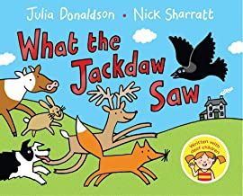 | Blown Away by Rob Bidduloph (supporting friends)  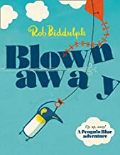 | Rain Before Rainbows:  by Smriti Halls  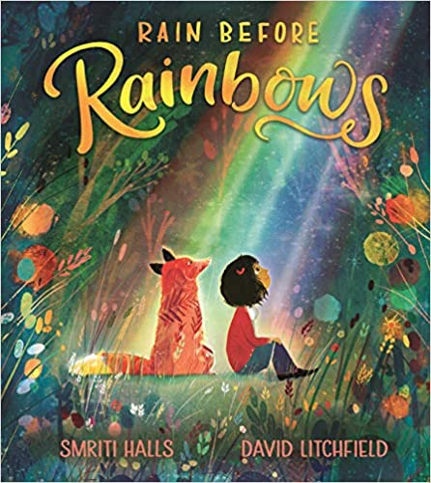
4 | The Boy at the Back of the Class – Orjal Q.Rauf  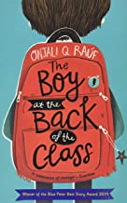 | Oliver Twist (abridged) – Charles Dickens  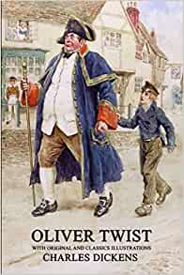 | Julius Caesar  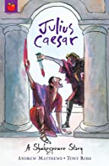 | The Wolf Wilder – Katherine Rundall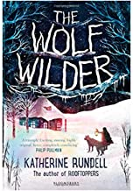 | The Wrong Shoes by Tom Percival  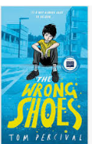 | The Little Prince by Antoine de Saint-Exupéry  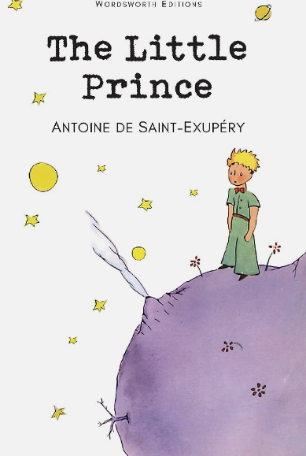
Picture books linked to Hist/Geog/Sci | The Orchard Book of Greek Myths by  Geraldine McCaughrean  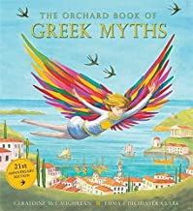 | A Christmas Carol by Charles Dickens  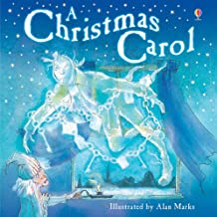 |  | The Drop in my Drink  by Christopher Coady and Meredith Hooper  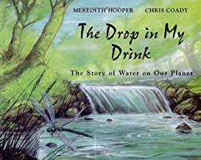 | The buildings that made London – David Lang  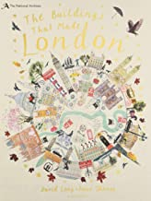 | The Great Fire of London: Anniversary Edition of the Great Fire of 1666  by Emma Adams  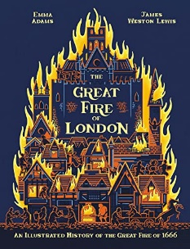
Poetry | Poetry:  Where my  Wellies Take  Me by Michael  Morporgo  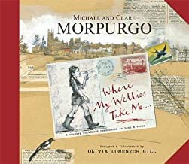 | Poems to be Read Aloud by Joseph Coelho  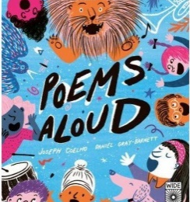 | Still I Rise by Maya Angelou  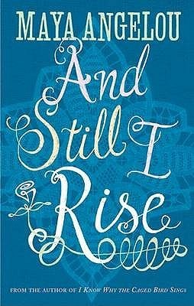 | Migration - On the Move by Michael Rosen  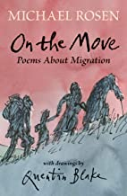 | Around the World in Eighty Poems by James Berry  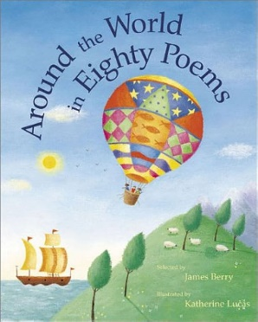
Everyone’s Welcome | The First Slodge by  Jeanne Willis and  Jenni Desmond (Sharing the World)  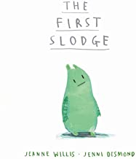 | The Flower by  John Light  (Turning the dull in  to the beautiful)  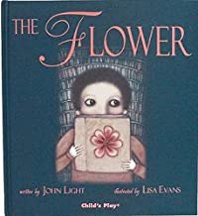 | Dreams of Freedom  by Mixed authors  (What we should  have the freedom to  do)  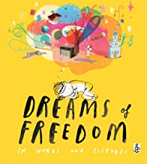 | We're All Wonders  by R J Palacio  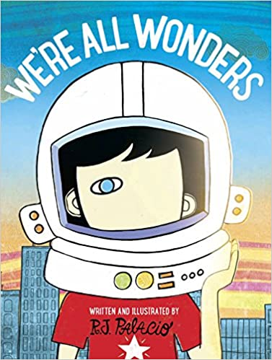 | Beegu by Alexis Deacon  (being lost in the unknown)  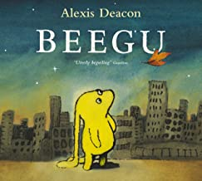 | King and King by  Linda de Hann and  Stern Nijland  (Relationships)  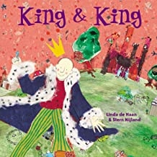
5 | BAGHDAD/SPATIAL | BRITISH EMPIRE/MOUNTAINS | FRENCH REVOLUTION/UK | SLAVE TRADE/AUSTRALIA | INDUSTRIAL REV/NEW ZEALAND | VICTORIANS/LOCAL STUDY
 | Windrush Child – Benjamin Zephaniah  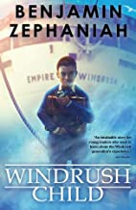 | Mayowa and the Sea of Words  By Chibundu Onuzo  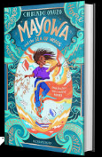 | Romeo and Juliet  Abridged Versions of:  Robinson Crusoe  Black Beauty  Gulliver’s Travels  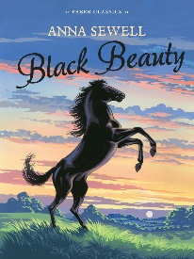  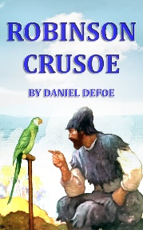  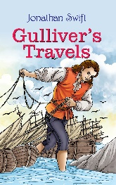  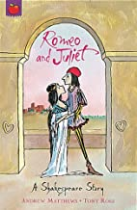 | Pig Heart Boy – Malorie Blackman  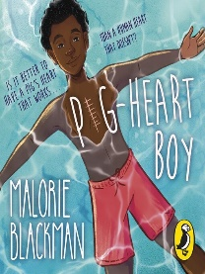 | Year 5 Literacy Event Book - TBC | Outlaw -Michael Morpurgo  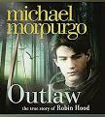
Picture Books linked to History/Geog/Sci | The Proudest Blue: A Story of Hijab and Family  Book by Ibtihaj Muhammad and S.K. Ali  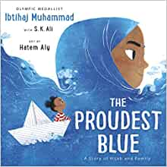 | Picture Book: First to  the Top: Sir Edmund  Hillary's Amazing  Everest  Adventure Hardcover  – May 1, 2016  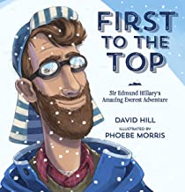 | Migration  Mike Unwin & Jenni Desmond  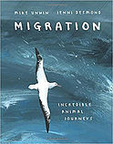 | Illegal - - Eoin Coiffer  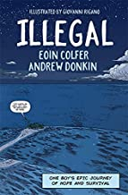 | Hidden Figures – The True Story of 4 Black Women and the Space Race 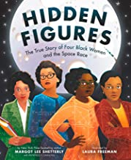 | The Pebble in my pocket – A history of Earth by Meridith Hooper  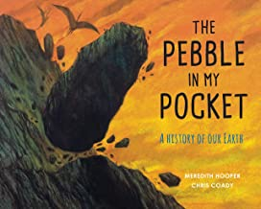
Poetry | The Lonely Traveller by Andrea Brown | Poetry: The Eagle  – Alfred Tennyson |  | The Book of Hopes: Words and Pictures to Comfort, Inspire and Entertain  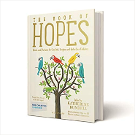  by Katherine Rundell | 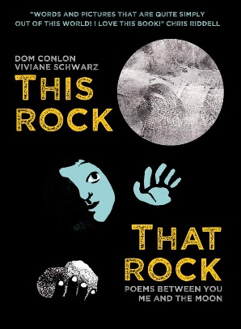  This Rock, That Rock – Poems between you and the moon – Dom Conlon
Everyone’s Welcome | Stevie Wonder (Little People, BIG DREAMS)  by Maria Isabel Sanchez Vegara  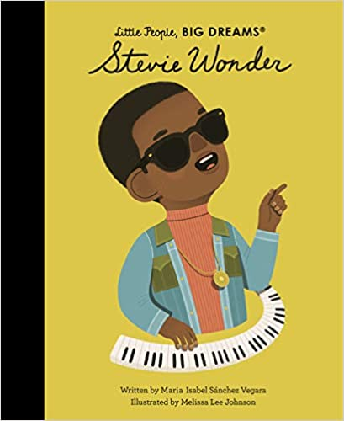 | Acceptance is my Superpower: A children’s Book about Diversity and Equality  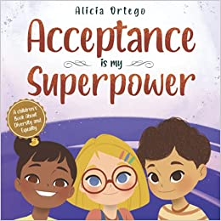 | The cow who Climbed a  Tree by Gemma Meino -  Trying new things  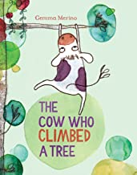 | Perfectly Imperfect Stories: Meet 29 inspiring people and discover their mental health stories:  by Leo Potion  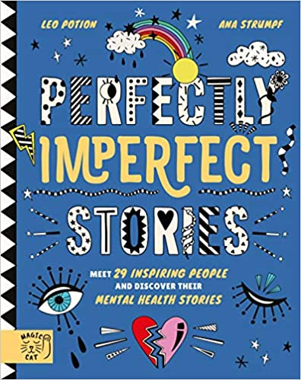 | All the Ways to be Smart  by Davina Bell  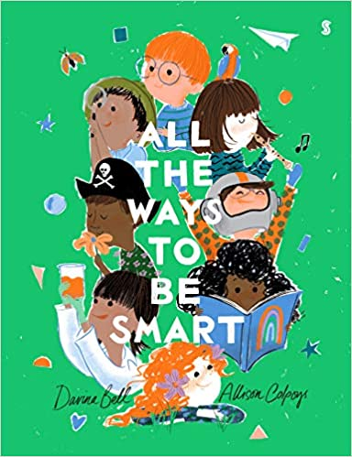 | The Thing by Simon Puttock  and Daniel Egneus –  (life in a new  country  Friendship and the meaning  of life)  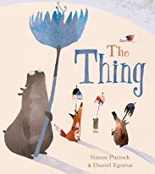
6 | WW1/Spatial/Human Body | Suffragettes/N.America/Plants | History of Human Rights/ Globalisation/Light | Rise of Hitler/ Africa/Electricity | WW11 and the Holocaust /S.America | The Cold War/British Issues
 | The Final Year  Matt Goodfellow  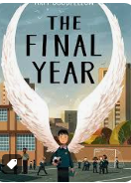  Abridged versions:  Around the World in Eighty Days by Jules Verne  The Railway children by Edith Nesbit 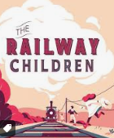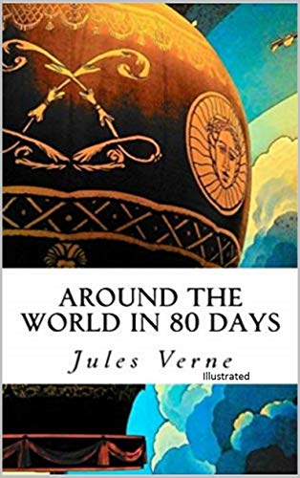 | Omar Rising by Aisha Saeed.  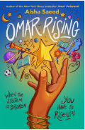 | Macbeth script and comic  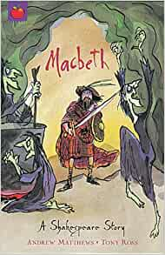 | When the Sky Falls by Phil Earle  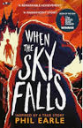 | Ways to be Me by Libby Scott  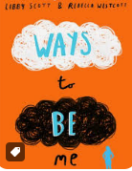 | The Boy Who Harnessed the Wind  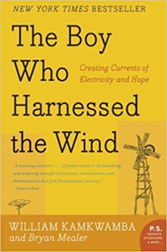  by William Kamkwamba
Picture Books linked to History/Geog/Sci | History: Picture Book:  Suffragettes: The  Battle for Equality  by David Roberts  (Non-Fiction)  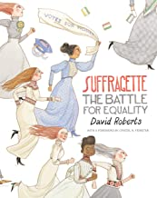 | History: The Best Christmas Present in the World – Michael Morpurgo  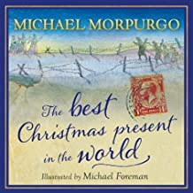 | Every Human Has Rights: A Photographic Declaration for Kids  by National Geographic Kids, Mary Robinson  (Non-Fiction/Poetry)  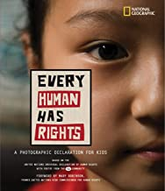 | History: Rose Blanche -Ian McEwan  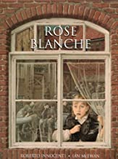 | Geography: Ada's Violin: The Story of the Recycled Orchestra of Paraguay  by Susan Hood  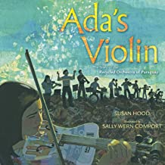 | Geography: The Story of Climate Change  by Catherine Barr (Non – Fiction)  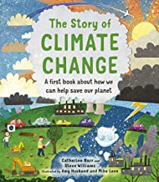
Poetry | Stars with Flaming Tails by Valerie Bloom  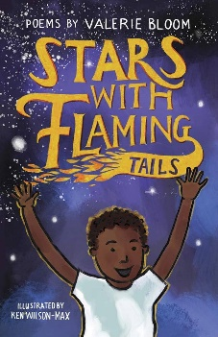 | Dulce Et Decorum Est | Shakespeare for Every Day of the Year  By Allie Esiri (One a day for term)  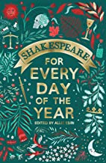 |  | In Flanders  Fields by  John McCrae
Everyone’s Welcome | King of The Sky  by Nicola Davies  (Starting a new)  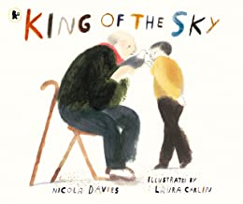 | Where the Poppies Now  Grow by Hilary  Robinson and  Martin Impey -  (war  and Peace)  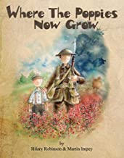 | The Silence Seeker by Ben Morley & Carl Pearce  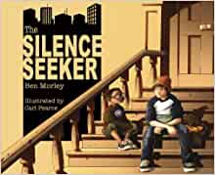 | How to Heal a Broken Wing by Bob  Graham – (helping people to heal)  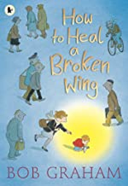 | My Princess Boy  by Cheryl Kilodavis  (boys dressing as  girls)  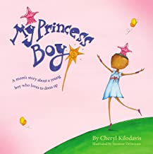 | And Tango makes Three by Justin  Richardson and Peter Parnell  (Relationships)  

